API Testing
API testing using Postman.

1. Objective of API Testing
The objective of API testing is to verify that backend services of the Breakout web application work correctly, return valid responses, and handle user requests properly. API testing is performed using Postman.

2. Identified APIs Used by Breakout
Breakout is a Shopify‑based e‑commerce application. The following APIs were identified using the Browser Network tab:

API Name | Method | Endpoint
View Cart API | GET | /cart.json
View Cart with Item API | GET | /cart.json
Add Product to Cart API | POST | /cart/add.js
Change Cart Quantity | POST | /cart/change.js
Remove Product from Cart | POST | /cart/change.js

3. API Test Environment
- Tool Used: Postman
- API Type: REST
- Authentication: Session Cookies
- Data Format: JSON
Cookies are required to maintain session state while testing cart APIs.

4. API Test Cases

API‑TC‑01: View Cart (Empty Cart)
- Method: GET
- Endpoint: /cart.json
- Pre‑Condition: Cart is empty
- Steps:
  - Open Postman
  - Send GET request to /cart.json

- Expected Result:
  - Status code 200
  - item_count = 0
- Actual Result:

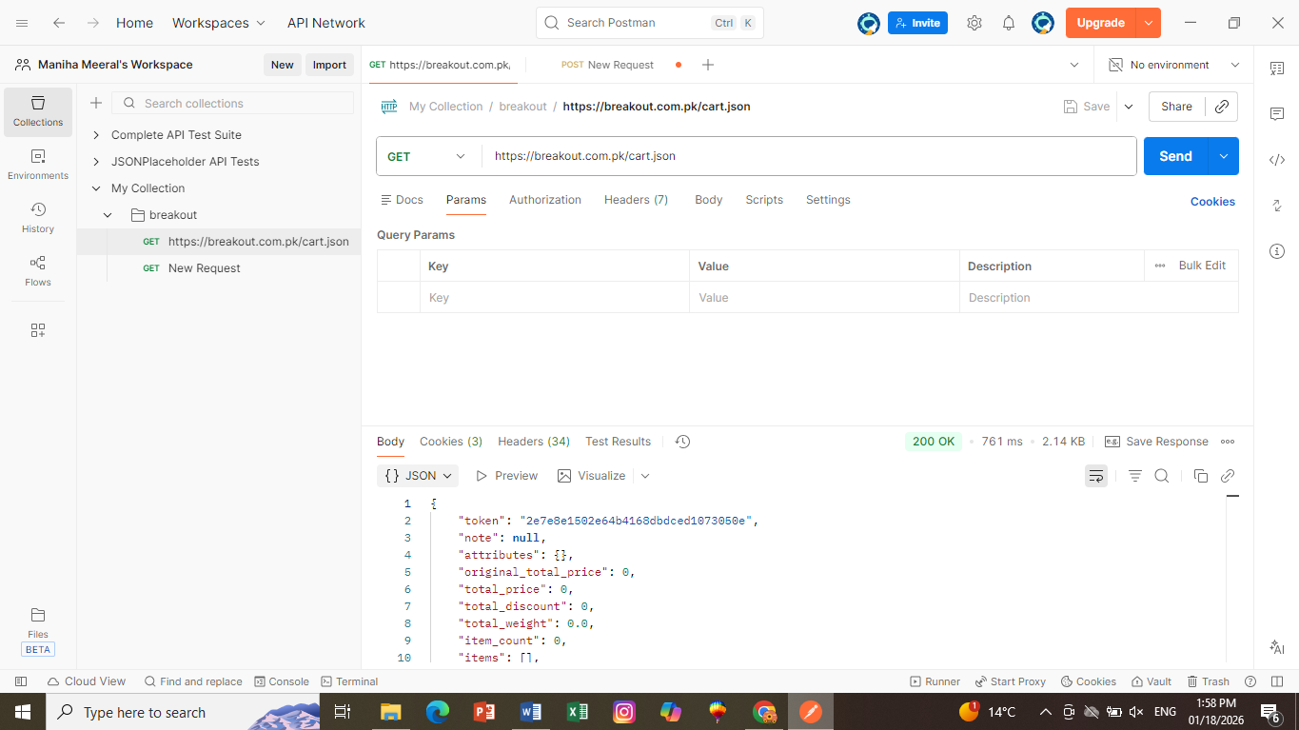

- Status: Pass

API‑TC‑02: View Cart (With Items)
• Method: GET
• Endpoint: /cart.json
• Pre-Condition: A product (e.g., Oversized Varsity Jacket) has been added to the cart.
• Execution Steps:
- Add a product to the cart via browser.
- Send GET request to https://breakout.com.pk/cart.json in Postman with session cookies.
• Expected Result:
- Status code 200 OK
- item_count > 0
- items array contains at least one product object
• Actual Result:
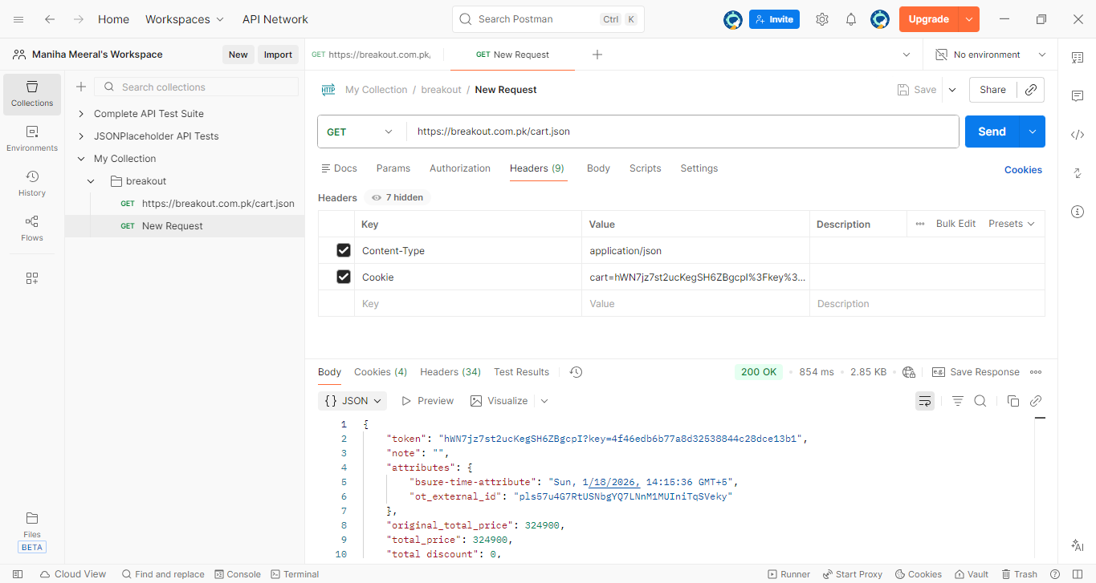

• Status: Pass

API‑TC‑03: Add Product to Cart
- Method: POST
- Endpoint: /cart/add.js
- Headers:
  - Content‑Type: application/json

- Body:
{
"id": 44400831856694,
"quantity": 1
}
- Expected Result:
  - Status code 200
  - Product added successfully
- Actual Result:

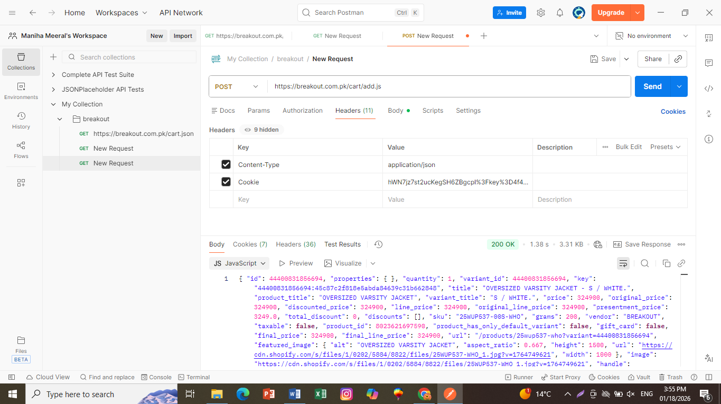

• Status: Pass

API‑TC‑04: Change Cart Quantity
- Method: POST
- Endpoint: /cart/change.js
- Body:
{
"line": 1,
"quantity": 3
}
- Expected Result:
  - Status code 200
  - Quantity updated

- Actual Result:

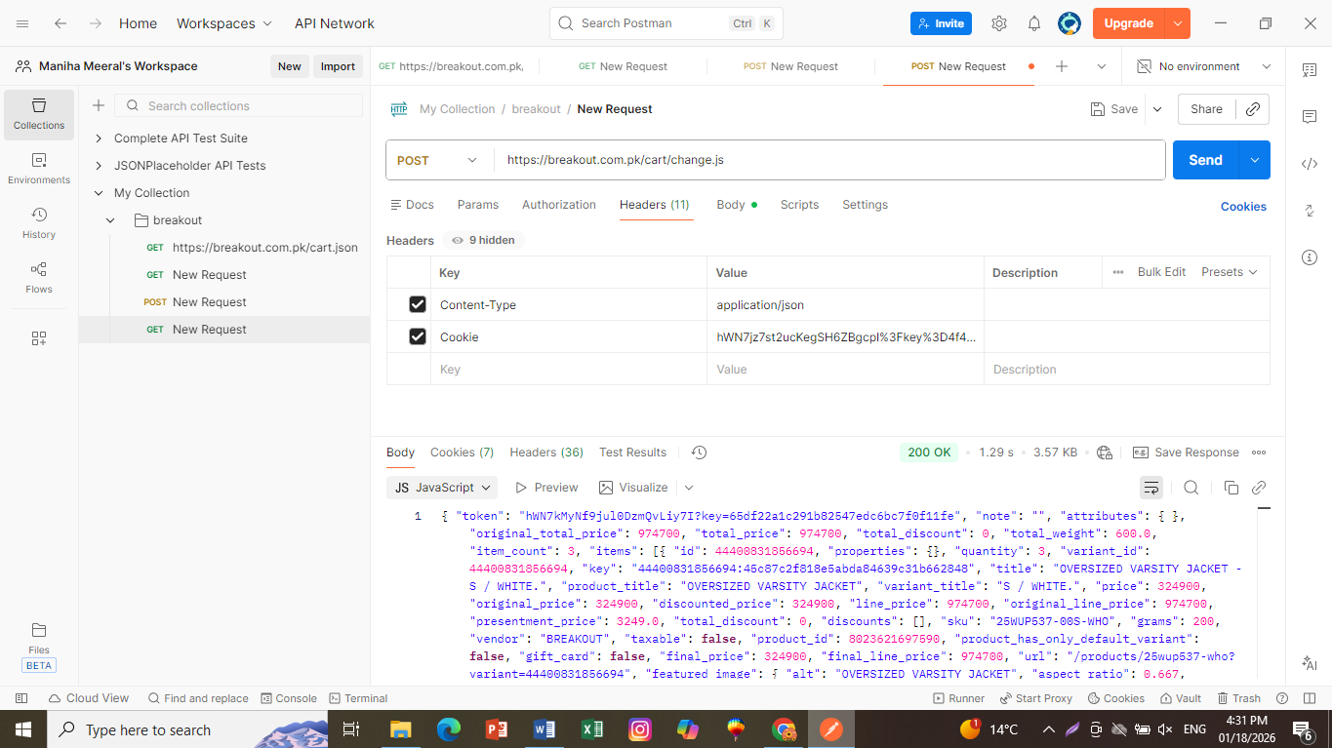

• Status: Pass

API‑TC‑05: Remove Product from Cart
- Method: POST
- Endpoint: /cart/change.js
- Body:
- {
- "line": 1,
- "quantity": 0
- }

- Expected Result:
  - Product removed from cart
- Actual Result:

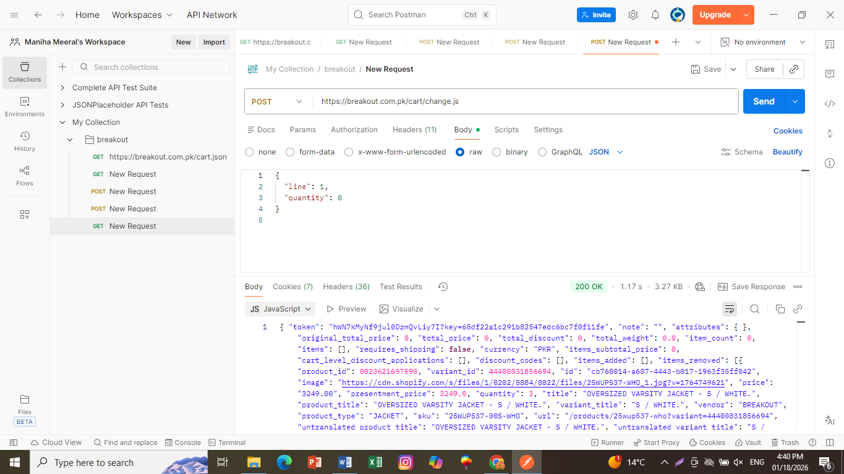

• Status: Pass

API‑TC‑06: Empty Cart
- Method: POST
- Endpoint: /cart.js
- Headers:
  - Content‑Type: application/json
- Expected Result:
  - Cart is empty

- Actual Result:
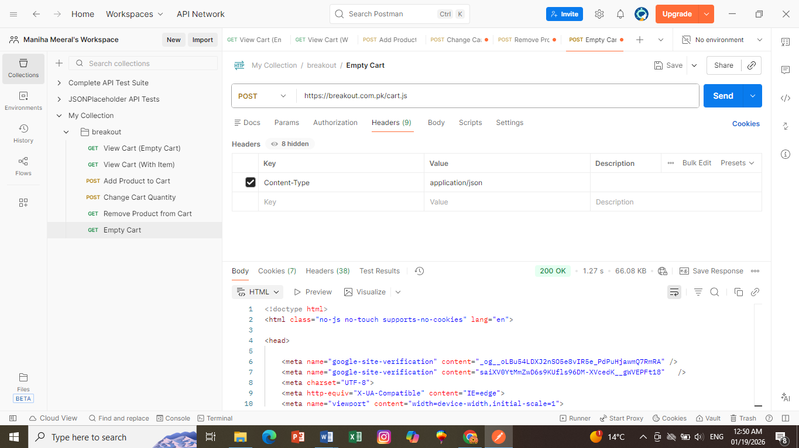
• Status: Pass

5. Assertions Used in Postman
The following assertions were added in Postman Tests tab:
- Verify status code is 200
- Verify response time is less than 2000ms
- Verify response body contains cart data
Example assertion:
pm.test("Status code is 200", function () {
pm.response.to.have.status(200);
});

7. Conclusion of API Testing
The API testing of the Breakout web application confirmed that cart‑related APIs function correctly for valid requests and return appropriate error messages for invalid inputs. This ensures reliability and correctness of backend services.

